Minutes of CMAC Board Meeting 8/25/14

Held at Yankee Grill, Renton

Present:
Alan Lauba
Angela Niemann
Brian Dennehy
Brian Jannsen
David Thomson
Fred Wurden
KC Holm
Kelly McCann
Lynne Bielaski
Paul Stamnes
Peter O'Kane
Tom Honeybone

Reporting / Action Items

Approval of minutes
Motion to Approve Minutes of July 21st Meeting: Proposed Peter O’Kane, Seconded by Angela Niemann, Approved Unanimously

Director’s Report – Alan (see written report)
- Sun Peaks sign up going out this week - folks can sign up for full package that includes food, lift ticket, or can stay with parents. Will include $100 coaching fee.
- Colorado camp sign up also going out this week: 4 coaches, 20 athletes already signed up - shooting for 7 to 1 ratio athletes to coach
- Staff update - will send update later this week, plenty of good coaches in the pipeline - looking good for U12 & U14, Prep staffing still a concern
- Race calendar will be locked by Friday. Alan will updatie website ahead of Sept 14th Picnic
- Trailer & Shack: old shack needs electrical work & need to move out the b-nets to facilitate work
- Video cameras: bought $250 Sony cameras x 2. Intention is for Alan and Scott to drive coach development – Alan & Scott will review video with coaches and provide coach with advice on their development
- AMP Scott has added physical training details to website
- Equipment: Alan still to do inventory & get ordering in place
- Scott's role will expand to include Coach Development
- FIS & U16 will train & race more often together this coming season
- Matt Hammond is developing quickly as FIS coach
- Saas Fee - spectacular, sharing the hill with lots of high level Slalom & GS skiers providing great examples to CMAC skiers, snow was extremely good especially in comparison to Mt Hood

Program Administrator – Dale (see written report)

Finalize program options (review proposal on U14)
Brian Dennehy presented proposal to create additional lower commitment U14 program option
Alan highlighted primary concerns: would we get enough participation? & would there be enough hill space?
Dale's poll says there are between 6-10 rising 1st year U14s who would join the program, but without it would leave - Time is the primary issue, not cost
Alan explained that price would need to be quite high to accommodate coaching fees (Weds/Thurs/Fri are low cost to CMAC), KC thinks it's ok to price it to encourage participation in the full program, BrianD comfortable with pricing program to encourage participation in full program
Kelly flagged that it’s Important to ensure that participants can only take advantage of the program for 1 year of U14
Fred proposed alternative might be to use FFE to subsidize folks we want to retain - we know who are the candidates for this "scholarship" & offer them a rebate
Fred reminded the board that FFE is open to all & that families with concern over program costs are encouraged to apply.
Kelly explained concern that parents of full time athletes will complain that less committed athletes are in the same groups
Action: Alan to call each of the 6 families by Friday 8/29 to explain the options so they can understand the value and costs of the program. Alan's goal is to sell them on staying in the program at the current price. Alan to report back to board in email.

Finalize program costs
Proposal to increase program costs already circulated.
Fred suggested we reduce % increase of Saturday Prep Program (limit to 8% increase) to ensure that entry level athletes don't pay disproportionately for higher level program costs such as coach's travel.
Alan flagged issues driving loss from previous season: didn't make profit on races, low snow led to increased coach travel
Motion: Lock Program Prices with no changes to proposal: Proposed Brian Dennehy, Seconded KC Holm, Approved Unanimously
Information from Lynne: 15 athletes got refunds totalling $7K
Lynne wants us to more closely scrutinize refund policy / guidelines. Brian JAnnsen suggested we consider offering cancellation insurance. Brian Dennehy suggested documenting process to provide transparency and set expectations.
Action: Angela draft refund policy to post to website

Outstanding Board Actions
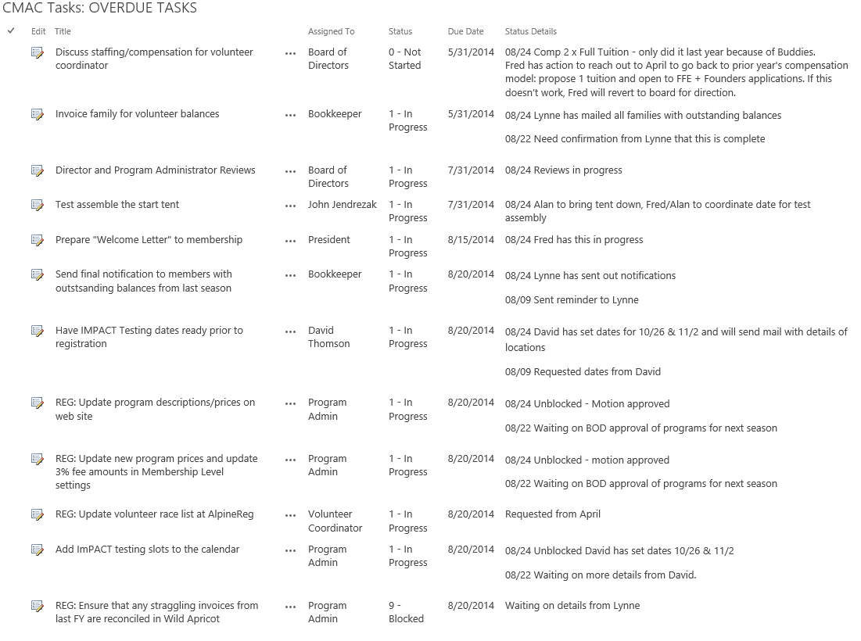

Work Group report outs

Operations
Action: BrianD recruit someone to help drive U12 Championships (potentially Hillary O’Hara).
Will work with Louis to nail race admin, tee shirts. Might want to consider doing trial run of the dual race maybe over Christmas camp. Consider using wireless timing.

Sponsorship/Fundraising – Peter/Brian J.
BrianJ - requested help from other board members to reach out to make personal asks for new sponsors. Action: Fred - will include in Welcome email.
Action: Dale to create email address for each of the work groups
Fred: pursuing Microsoft OSG sponsorship
Fred: need to track and stay in touch with Alumni to get contribute to FFE on recurring basis, also potential for sponsorship. Action Brian / Peter figure out strategy
Got $25K in pledges to FFE. Some feedback suggesting that folks preferred the ability to opt say yes to donation volunteer refund (vs yes or no)

Treasurer/Finance – Paul/Lynne
Now able to finalize budget. Will present final budget at next meeting.
Fred wants Paul/Lynne to develop financial scorecard. Ideal would be that some subset of it could be published. As Non Profit want to be able to say % of contributions that were put to work. Action: Paul define financial scorecard
Action for other workgroup leads: develop core metrics which will be presented at next CMAC end of Season Banquet.
Action: Fred confirm costs of helicopter, trailer pad teardown, steel, welding, excavator work
Action: Alan confirm how much FFE money required for additional video cameras

New Business?

Facilities
Need log stacking crew 1 weekend + 1 weekend to stain
Hill space - Action Alan to get meeting with Scott & John to get it locked in

Facilities - CMAC needs to pay to rip out the trailer, but will keep pad & need to enable Scott to put in sceptic & wiring. David has friend with trucking business (Action: email contact info to Fred)

Picnics
KC has sent out picnic emails – agreed $50 per pre-season social event for food / drink
Action: KC work with FEE to breakout targets for FFE social funding per age group

Exec Committee
Board went into execution session at 8:18pm
Board left executive session at 8:40pm

Contract renewals
Motion to approve Alan’s new contract: Proposed KC Holm, Seconded Paul Stamnes, Approved Unanimously

Adjournment: 8:45 p.m.

